Tasks To Be Performed:

1. Deploy a Kubernetes cluster for 3 nodes

2. Create a NGINX deployment of 3 replicas

**Procedure:**

First we need to install the kubernetes

On Master and Slave:  
  
  
sudo apt-get **update**  
sudo apt **install** docker.io -y  
sudo apt-**get** **install** -y apt-transport-https ca-certificates curl gpg  
sudo mkdir -p -m 755 /etc/apt/keyrings  
curl -fsSL https://pkgs.k8s.io/core:/stable:/v1.28/deb/Release.key | sudo gpg --dearmor -o /etc/apt/keyrings/kubernetes-apt-keyring.gpg  
echo 'deb [signed-by=/etc/apt/keyrings/kubernetes-apt-keyring.gpg] https://pkgs.k8s.io/core:/stable:/v1.28/deb/ /' | sudo tee /etc/apt/sources.list.d/kubernetes.list  
sudo apt-**get** **update**  
sudo apt-**get** **install** -y kubelet kubeadm kubectl  
sudo systemctl **enable** --now kubelet  
  
**On** **Master**:  
sudo kubeadm init --apiserver-advertise-address=privateipofmaster  
  
Note: You need **to** **replace** “private_ip_of_master” **with** the actual **private** ip **of** your kubernetes master.  
  
Paste the Token **on** **Slave**  
  
**On** **Master**  
  
mkdir -p $HOME/.kube  
sudo cp -i /etc/kubernetes/admin.conf $HOME/.kube/config  
sudo chown $(**id** -u):$(**id** -g) $HOME/.kube/config  
  
Installing Calico  
curl https://raw.githubusercontent.com/projectcalico/calico/v3.27.2/manifests/calico.yaml -O  
  
kubectl **apply** -f calico.yaml  
  
kubectl **get** nodes

**apiVersion**: apps/v1  
**kind**: Deployment  
**metadata**:  
 **name**: nginx-deployment  
 **labels**:  
 **app**: nginx  
**spec**:  
 **replicas**: 3  
 **selector**:  
 **matchLabels**:  
 **app**: nginx  
 **template**:  
 **metadata**:  
 **labels**:  
 **app**: nginx  
 **spec**:  
 **containers**:  
 - **name**: nginx  
 **image**: **nginx**:latest  
 **ports**:  
 - **containerPort**: 80

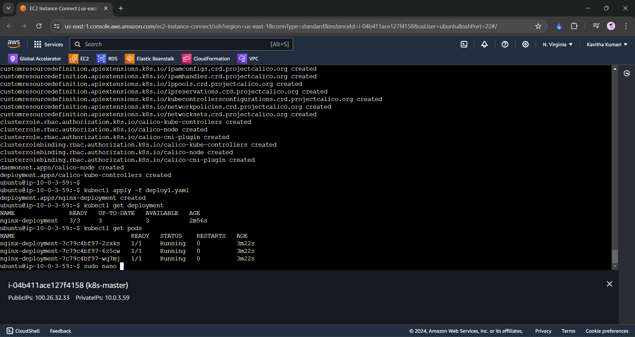

---------end---------